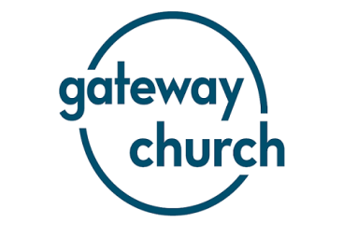
Nehemiah: Vision shaped by the book
Overview of the message:
Tim unpacked Nehemiah 9: 5 – 33, where the Jewish people speak out a prayer of remembrance, recalling the history of their people. In doing so they united around truths from their history that reminded them of God’s purposes and faithfulness towards them.
Key Points
PURPOSE – For years the Jews had been living in ruins, a constant reminder of their past failure. By recalling their history they were able to see God’s purposes in his continual pursuit of them.
PEOPLE – The Jews were united both in celebration and mourning. Their vision was acted out in community and unity.
PAST – The Jews prayed their history back to God. In doing so they reminded themselves of God’s continual faithfulness.

Questions

- How often do we reflect on the past, both our own and history? What are the benefits and problems we may encounter in doing this? How can we do this in a healthy way?

- In recalling their history, the Jews were able to see the bigger picture of God’s purposes. In what ways can we do the same? What is the bigger picture?

- What does it mean to outwork vision in a community?

- It is easy to forget what God has done in us. Take a moment to reflect and share when and where God has been faithful in your own life.

